Cloudtrail Monitoring

- Enable cloudtrail monitoring and store the events in s3 and cloudwatch log events.

Task on Monitoring- CloudTrail & CloudWatch

1) Enable cloudtrail monitoring and store the events in s3 and cloudwatch log events.
Task Title :
Enable CloudTrail and Store Logs in S3 & CloudWatch Logs
Objective :
Enable AWS CloudTrail to monitor all API events and store them securely in S3 and CloudWatch Logs for auditing and monitoring.
Prerequisites :
- IAM Admin / CloudTrail permissions
- S3 bucket (CloudTrail can create)
- CloudWatch Log Group / IAM role for CloudTrail

Step-by-Step Implementation (With Evidence)
Step 1: Create a CloudTrail Trail
Console Path:
AWS Console → CloudTrail → Trails → Create Trail
Explanation:
Creates a trail to capture management
Evidence:

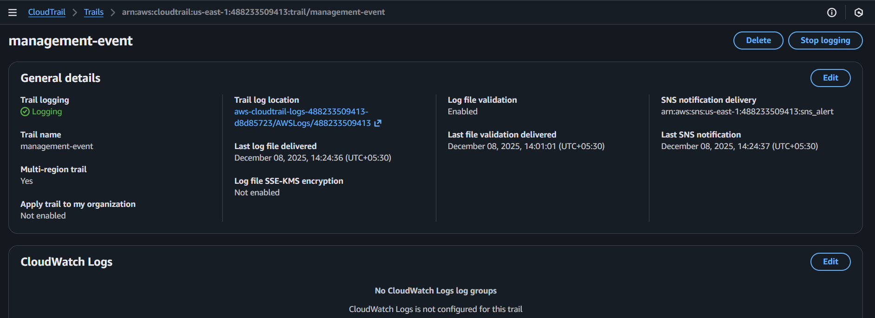

Cloud watch enabled
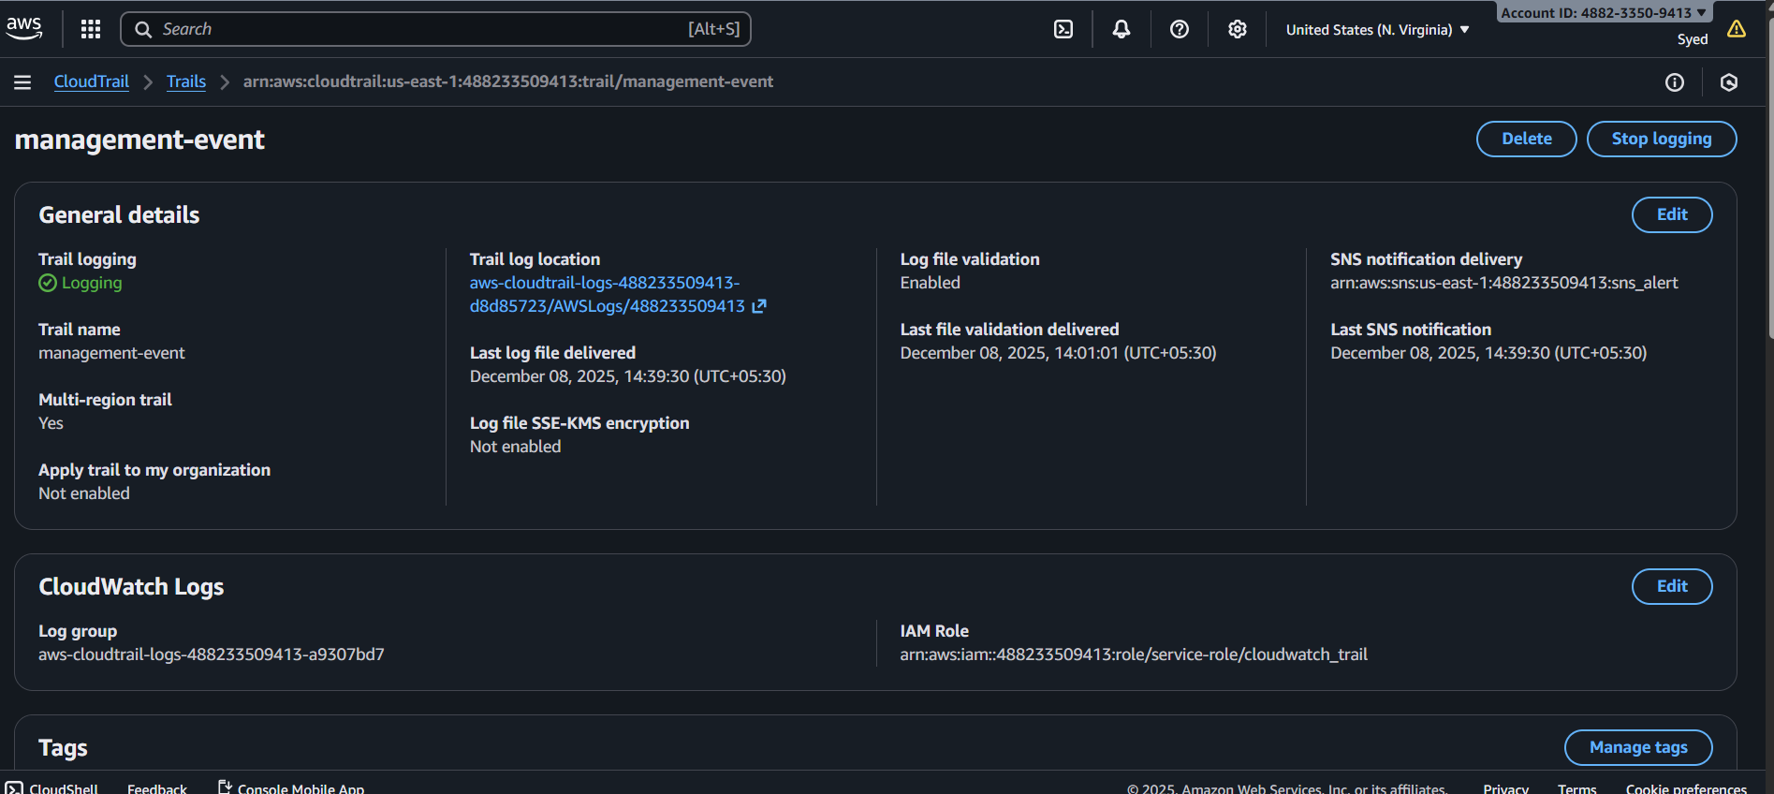

Monitoring the logs

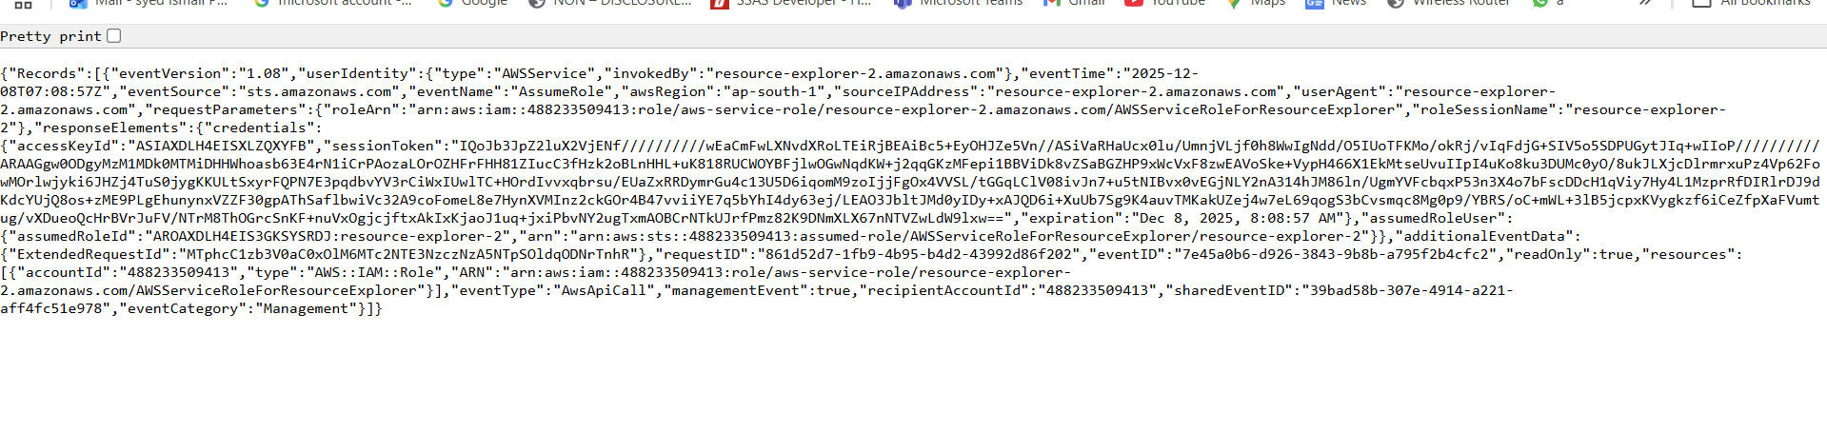

2.Enable SNS for cloudtrial to send alert on email.
Task Title :
Enable SNS Alerts for CloudTrail Using CloudWatch Metric Filters
Objective :
Send email notifications for critical CloudTrail events (e.g., unauthorized API calls).
Prerequisites :
- CloudTrail enabled
- CloudWatch Logs enabled
- Valid email address
- IAM SNS permissions

Step-by-Step Implementation (With Evidence)
Step 1: Create an SNS Topic
Console Path:
SNS → Topics → Create Topic
Name: cloudtrail-alert
Display name – cloudtrail-alert

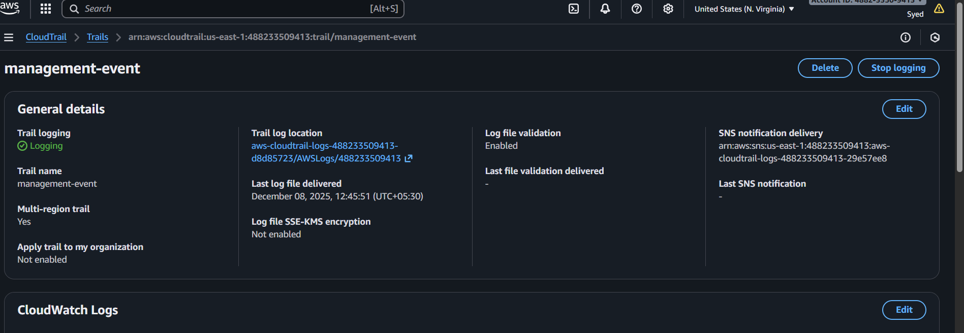
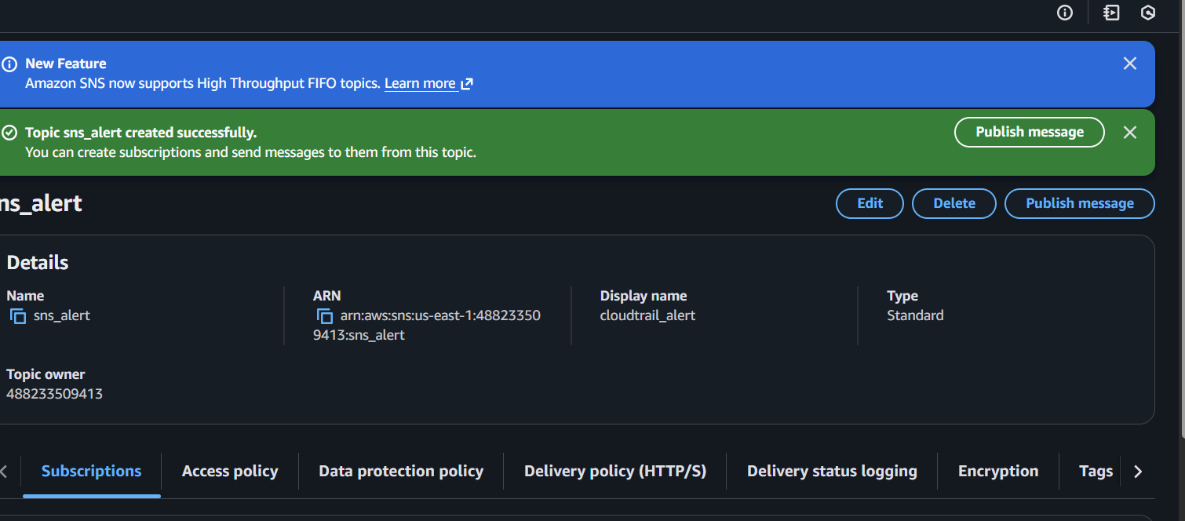

Protocol: Email
Enter your email.
Confirm subscription from your inbox.

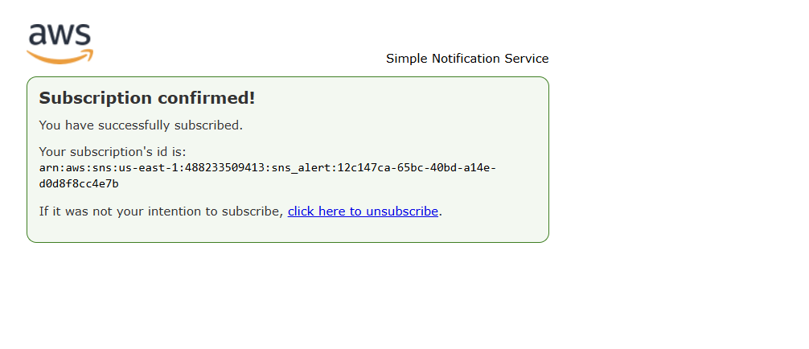
3) Configure cloud watch monitoring and record the cpu utilization and other metrics of ec2.
Task Title :
Install & Configure CloudWatch Agent on EC2 for System Monitoring
Objective :
Collect CPU, Memory, Disk, and EC2 status metrics using CloudWatch Agent.
Prerequisites :
- EC2 instance
- IAM Role with CloudWatch permissions
- SSH Access
- Internet access (or SSM)

Step-by-Step Implementation (With Evidence)
Step 1: Install CloudWatch Agent
SSH into EC2.
Amazon Linux:
sudo yum install amazon-cloudwatch-agent -y
Evidence:
(Terminal screenshot)
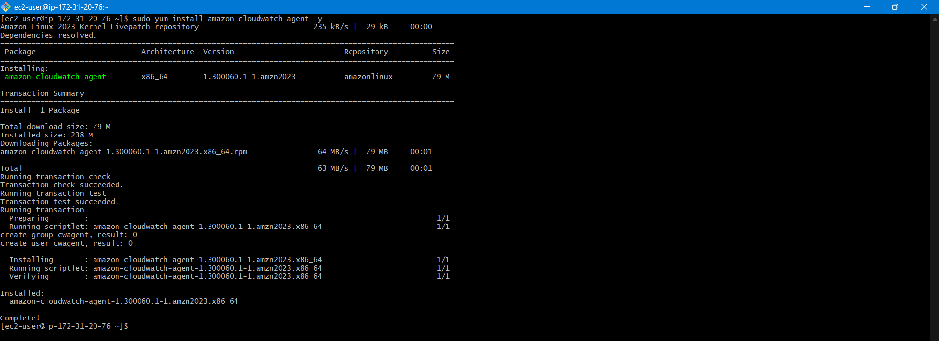
Step 2: Configure the Agent
Run config wizard:
sudo /opt/aws/amazon-cloudwatch-agent/bin/amazon-cloudwatch-agent-config-wizard
Evidence:
(Wizard terminal output)
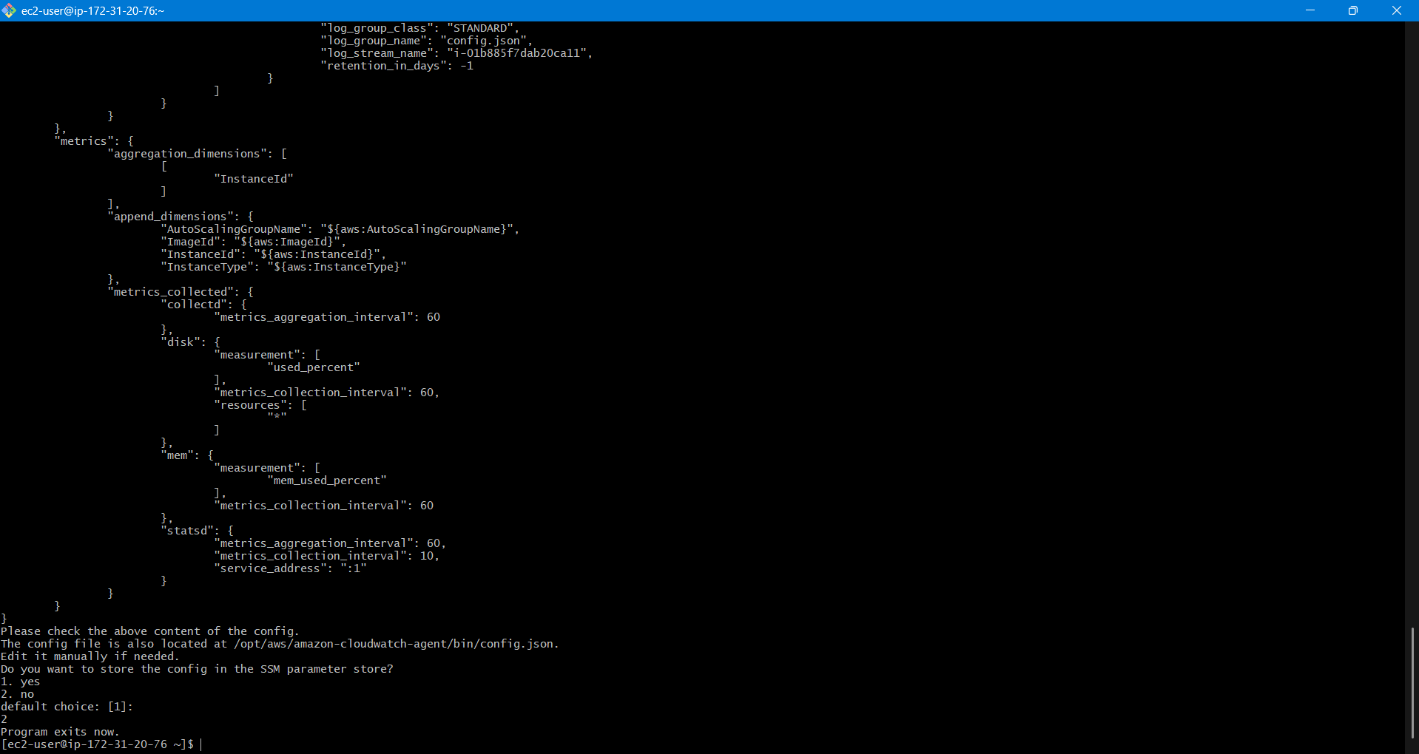
Step 3: Start the Agent
sudo systemctl start amazon-cloudwatch-agent
sudo systemctl enable amazon-cloudwatch-agent
Evidence:
(systemctl status agent screenshot)
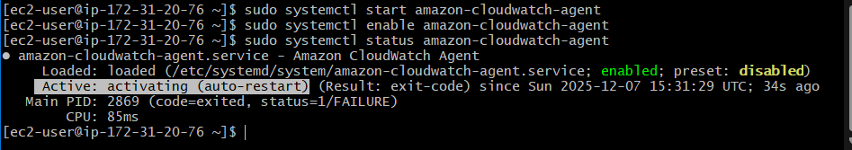
Validation Steps (With Evidence)
Validation 1: Agent Running
systemctl status amazon-cloudwatch-agent
Evidence: Screenshot
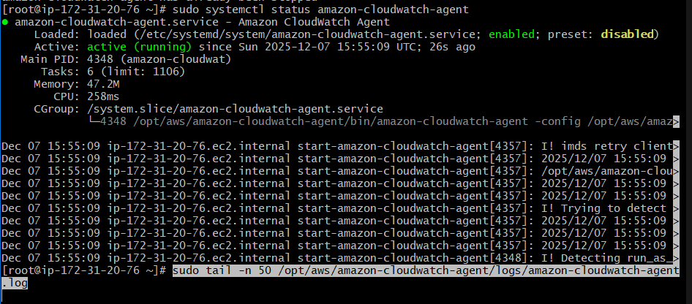
Validation 2: Metrics Visible
CloudWatch → Metrics → CWAgent namespace
Evidence: Screenshot
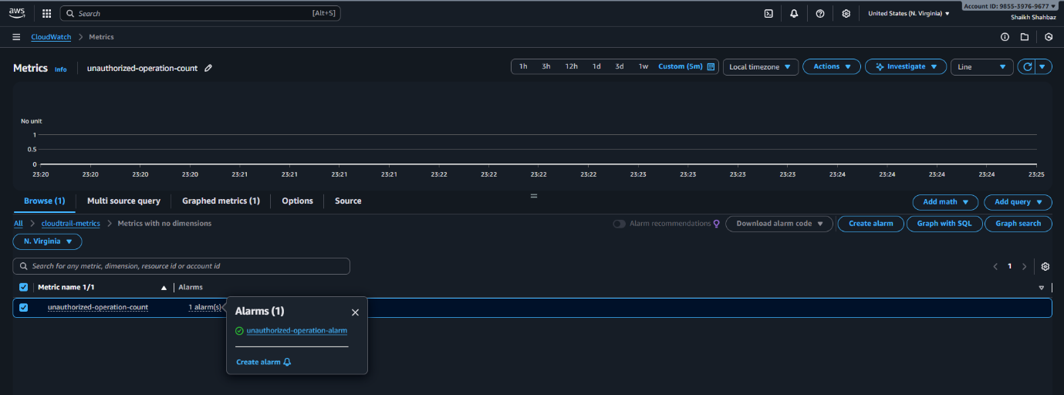
Issues Faced :
Had to wait for email and logs to form.
Conclusion :
CloudWatch Agent installed and EC2 metrics are available.

Step : Subscribe Email
Protocol: Email
Enter your email.
Confirm subscription from your inbox.
Evidence:
(Subscription confirmation screenshot)

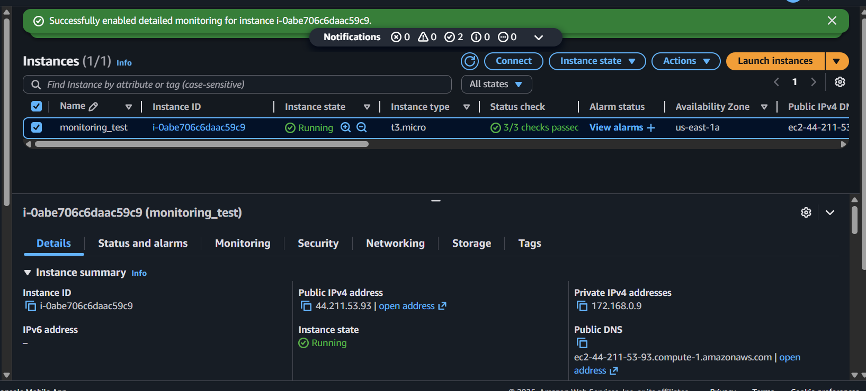

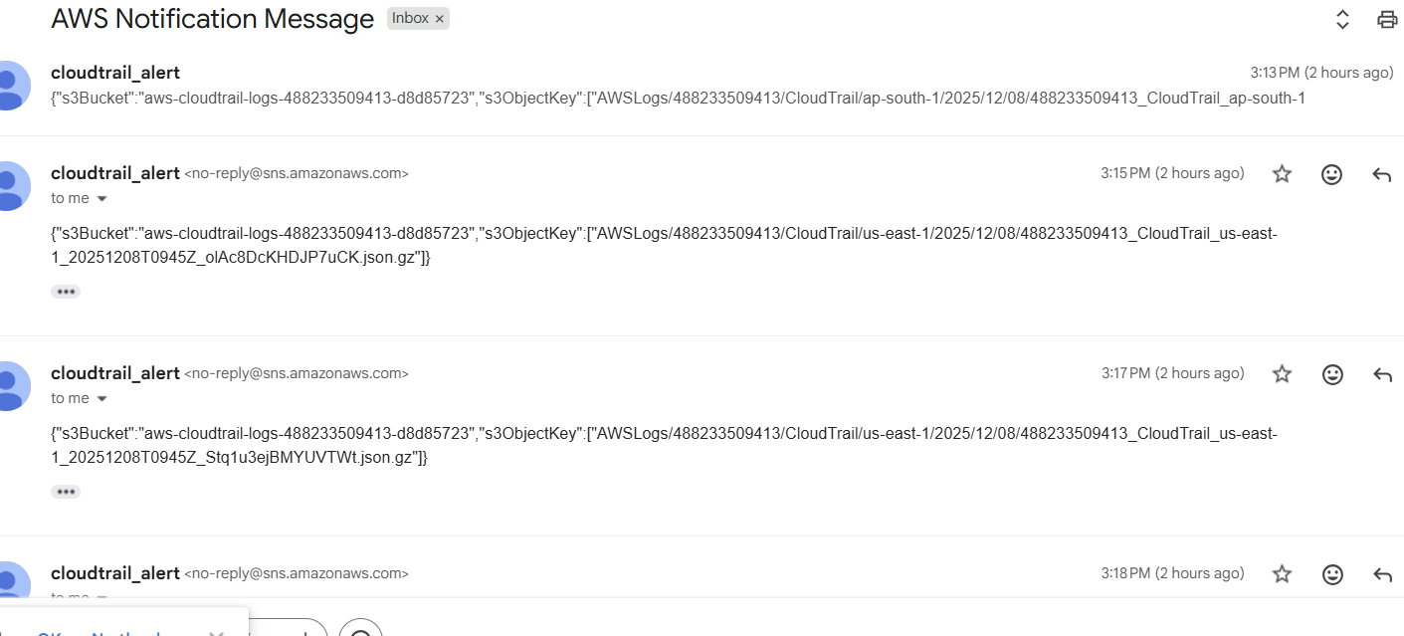

4) Create one alarm to send alert to email if the cpu utilization is more than 70 percent.

Task Title :
Configure CloudWatch Alarm for CPU > 70%
Objective :
Create a CPU alarm that triggers an SNS email notification when load exceeds 70%.
Prerequisites :
- SNS Topic
- CloudWatch metrics
- EC2 instance

Step-by-Step Implementation (With Evidence)
Step 1: Create Alarm
Console Path:
CloudWatch → Alarms → Create Alarm
Metric:
- EC2 → Per-instance metrics → CPUUtilization
Evidence:
(Metric selection screenshot)

Step 2: Configure Threshold
- Static threshold
- CPU > 70%
- Period: 5 minutes
Evidence:
(Threshold screenshot)

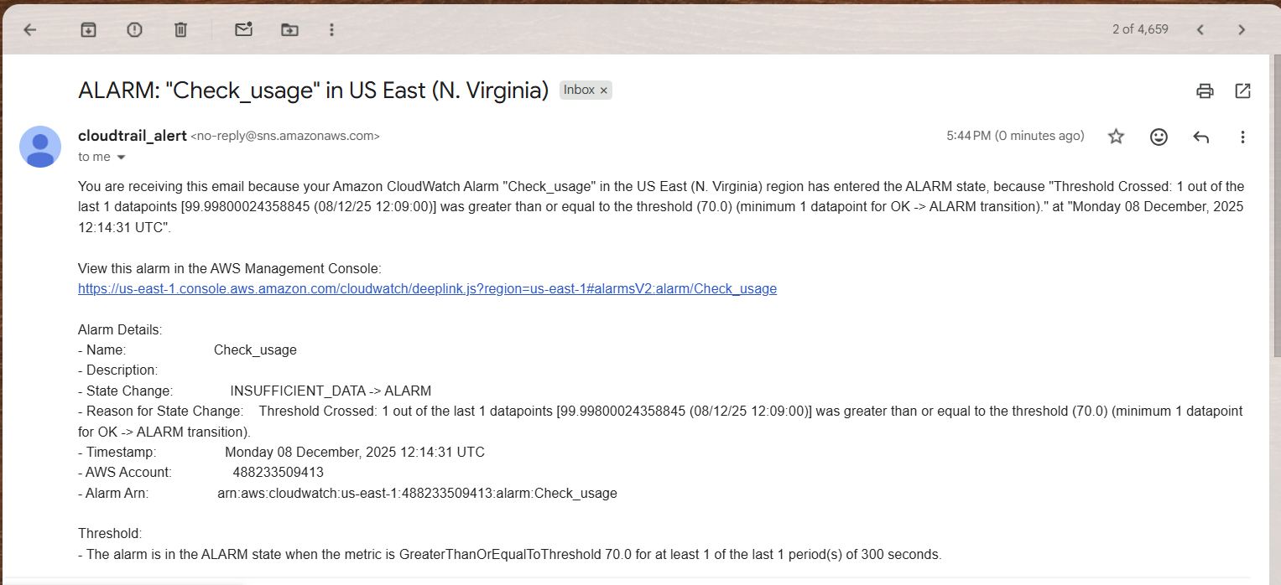

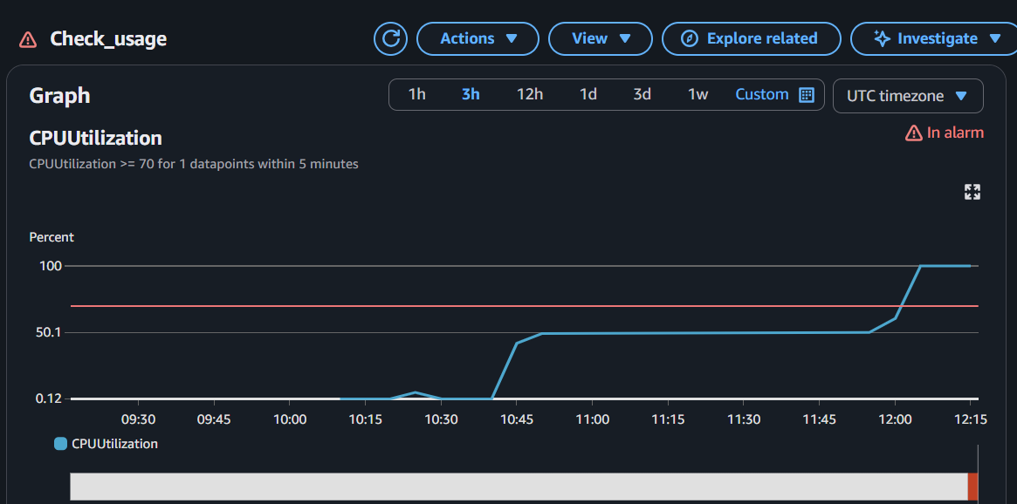

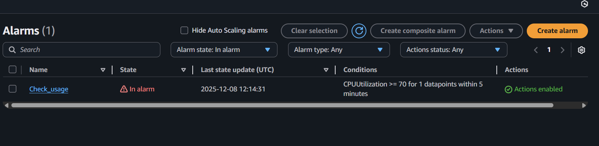

5.Create Dashboard and monitor tomcat service wether it is running o r not and send the alert.

Task Title :
Monitor Tomcat Service Using Custom CloudWatch Metrics
Objective :
Track Tomcat service uptime and trigger alerts if service stops.
Prerequisites :
- EC2 instance with Tomcat installed
- CloudWatch Agent or AWS CLI installed
- IAM Role with CloudWatch permissions

Step-by-Step Implementation (With Evidence)
Step 1: Create Tomcat Status Script
sudo vi /opt/tomcat-status.sh
Add:
#!/bin/bash
if systemctl is-active --quiet tomcat; then
status=1 (Service-active)
else
status=0 (Service-inactive)
fi

aws cloudwatch put-metric-data \
--metric-name TomcatStatus \
--namespace "Custom/Tomcat" \
--value $status
Evidence:
Screenshot of script

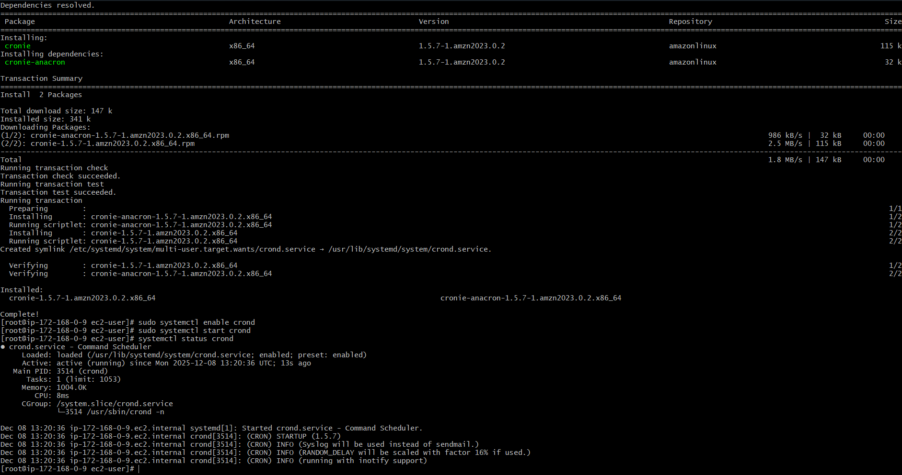
Step 2: Enable Script via Cron
crontab -e
Add:
* * * * * /opt/tomcat-status.sh
Evidence:
Cron screenshot

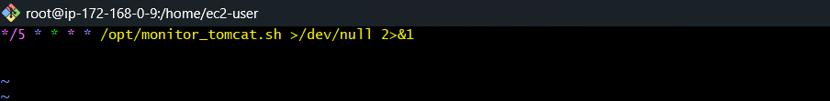

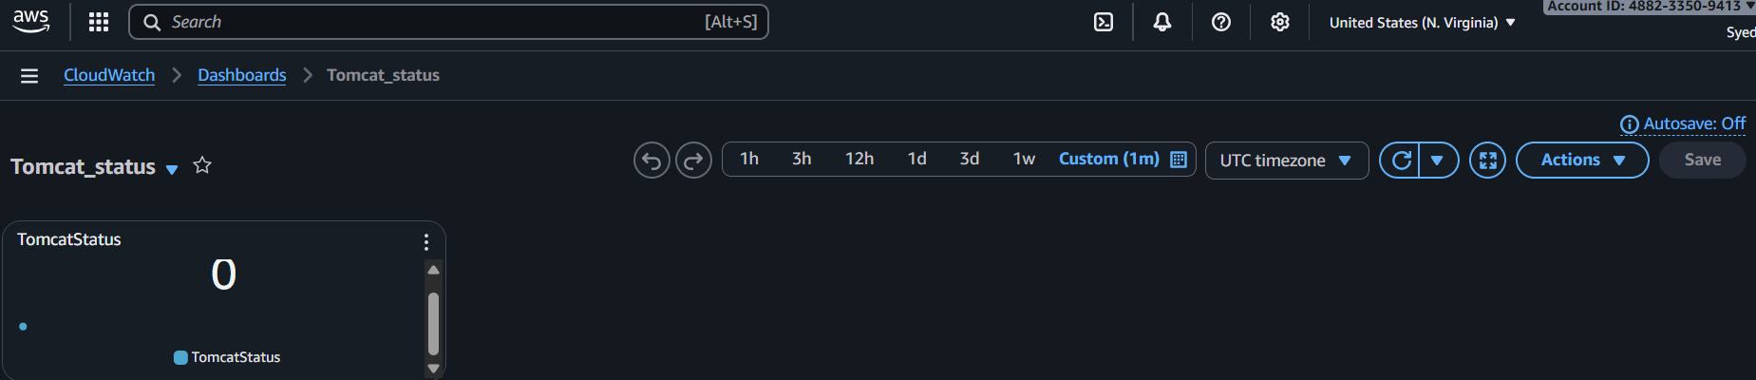

6) Create Dashboard and monitor nginx service to send the alert if nginx is not running.

Task Title :
Monitor Nginx Service Using Custom CloudWatch Metrics
Objective :
Monitor Nginx service health and receive alerts when it stops.
Prerequisites :
- EC2 with Nginx installed
- AWS CLI
- CloudWatch write permissions

Step-by-Step Implementation (With Evidence)
Step 1: Create Nginx Status Script
sudo vi /opt/nginx-status.sh
Add:
#!/bin/bash
if systemctl is-active --quiet nginx; then
status=1 (Service-active)
else
status=0 (Service-inactive)
fi

aws cloudwatch put-metric-data \
--metric-name NginxStatus \
--namespace "Custom/Nginx" \
--value $status
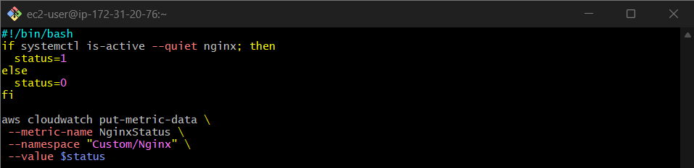
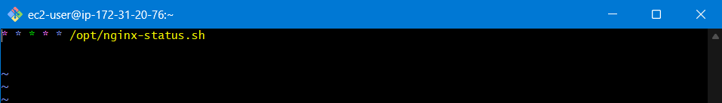

Step 3: Create Alarm for Nginx
Alert when:
NginxStatus = 0 (Service-inactive)
Evidence: Alarm screenshot

